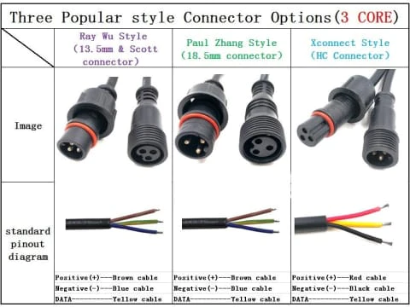
12 Volt 4-Pin
Used for RGB Floods
Male has threads, female has nut???
12 Volt 3-Pin
Used for 12 Volt Pixels
xConnect – Male has threads, female has nut
12 Volt 2-Pin
Used for power injection to 12 Volt pixels
Used for Rotating Beacons
Male has threads, female has nut???
5 Volt 3-Pin
Used for 5 Volt Pixels
Ray Wu or Paul Zhang – Female has threads, male has nut
5 Volt 2-Pin
Used for power injection to 5 Volt Pixels
Ray Wu or Paul Zhang – Female has threads, male has nut
24 Volt 3-Pin
Used for LED Neon Strips
Ray Wu or Paul Zhang – Female has threads, male has nut

